Stay Up Late’s Ordinary Conference

Application to speak at our conference

Your name:

…………………………………………………………
Address:

…………………………………………………………

…………………………………………………………

…………………………………………………………

Email:

…………………………………………………………
Phone number:

…………………………………………………………
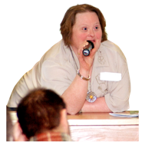 | About the conference  We want people with learning disabilities to speak at our conference.  We want to hear positive stories and examples of how people are living the lives that they want to lead.
 | We have written a ‘manifesto’, or list, of things that people with learning disabilities say they want in their lives.
We want people to speak on one of these topics.

Please tick to say which one of these you would like to speak on
(Please just pick one)

 | Recruiting my support staff, and choosing who supports me.
 | Having happy support staff who love their work
 | Having an active social life (and seeing my friends when I want to)
 | Choosing where I live, and who I live with
 | Choosing how I spend my time
 | Choosing what time I go to bed, and when to go home from events.
 | Having good relationships (including a love life)
 | Being active and welcome in my community
 | Having a proper paid job
 | How I’ve challenged disability hate crime
 | Please tell us a bit more about yourself and why you’d like to talk about this subject.
We really like to hear about positive changes it’s made in your life.
Please give us an example of this.
We want to make our conference as relaxed and accessible as possible.
So it’s up to you how you choose to present.
You could do a talk.
Show a film.
Sing a song.

Or something else, it’s up to you.

Please tell us how you would like to present your story about yourself
(You can be as creative as you like)

…………………………………………………………………….

…………………………………………………………………….

…………………………………………………………………….

 | The deadline to apply is 31st Jan ‘19
 | We will be in touch shortly after that to invite our chosen speakers.
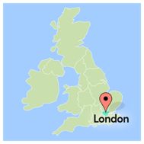 | You will need to be available to attend the whole of the day on 26th March ’19 in London.  10am – 4pm
If you have any questions please phone us on 01273 600438

Or email us at info@stayuplate.org
Return this application to:
info@stayuplate.org

or
Stay Up Late
Dorset Gardens Methodist Church
Dorset Gardens
Brighton
BN2 1RL

We look forward to reading your application.

