Quality Checker application form

Name:
…………………………………………………………………
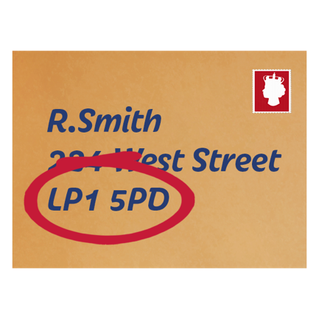 | Address:  …………………………………………………………………  …………………………………………………………………  …………………………………………………………………
Phone:

…………………………………………………………………

Email:

…………………………………………………………………

Please give the details of someone who can give us a reference for you.

Reference name:

…………………………………………………………………

Reference address:

…………………………………………………………………

…………………………………………………………………

…………………………………………………………………

Reference email:

…………………………………………………………………

…………………………………………………………………

…………………………………………………………………

Reference phone:

…………………………………………………………………

How do you know them?

…………………………………………………………………

Have you had a job before?

Yes / No
Please tell us about any job that you have had (either paid or unpaid):

Please tell us why you think you would be good at this job

Have you ever been cautioned by the police or convicted of a criminal offence?

Yes / No

Have you ever been referred to the children’s or adults ‘barred list’?

Yes / No
I confirm that the above information is all correct.

Signed:

…………………………………………………………………

 | If you are invited for interview we will ask you about any specific support needs that you may have, and how we could support you to make sure you could work with us.
Please return this form by email to:

Dee@stayuplate.org
Or post this form to:

Dee MacDonald, Stay Up Late
Dorset Gardens
Dorset Gardens Methodist Church
Brighton
BN2 1RL
 | Deadline for applications is 5pm on 18th July ‘18

Please use a separate piece of paper if you run out of room on this form.

