Streatham Space Project
Sternhold Avenue
London
SW2 4PA
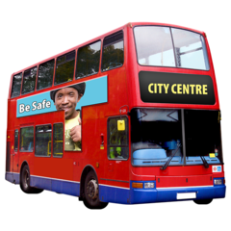 | London buses  You can take the 109, 118, 133, 159, 250 or 333 bus to Streatham Hill Stop C or Streatham Hill stop Q
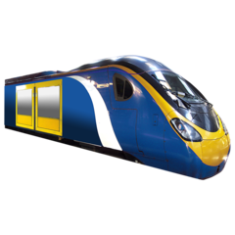 | The closest train station is Streatham Hill.  It is a 1 minute walk from the venue.
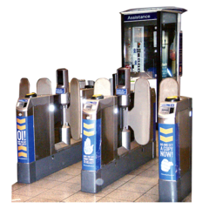 | The closest tube station is Tooting Broadway.  It is a 35 minute walk from the venue.
There is parking available at Streatham Hill train station.

Leigham Court Road car park is a 3 minute walk from the venue.

