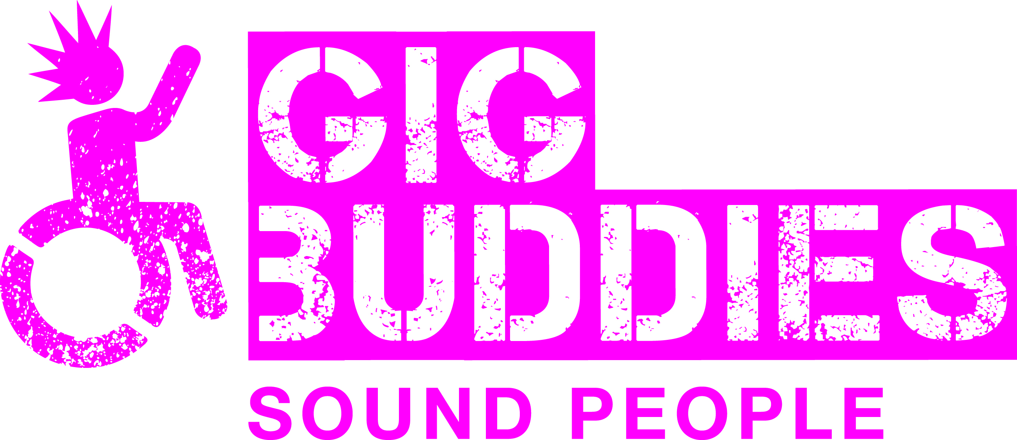

Stay Up Late

Campaign Co-ordinator

Information Pack

GENERAL INFORMATION
Stay Up Late was started as an awareness raising campaign by the band Heavy Load in 2006 and featured in the documentary film (also called Heavy Load and incidentally one of Mark Kermode’s top 5 documentaries of the 21st Century!). Heavy Load were concerned at the amount of people with learning disabilities missing out on gigs due to their support staff working inflexible shift patterns.

The exposure of the film enabled the campaign to reach a wide audience of people experiencing the same frustrations. Heavy Load didn’t want their work simply to be about raising awareness and in 2011 Stay Up Late became a registered charity committed to also bringing about real change.
Our aim is to promote full and active social lives for people with learning disabilities.

The geographical location of our work is predominantly in Sussex, delivering the Gig Buddies project.

However, Gig Buddies has now been replicated in other parts of the UK and in Sydney, Australia.
We continue to have a high profile nationally for the campaigning side of the charities work.
All of our income is derived from fundraising, and we rely on our well-established community links to achieve this.

Although the charity is still growing, we have a strong commitment to developing innovative projects that will enable people with learning disabilities to enjoy full and active social lives, and involve people with learning disabilities in the design, delivery and development of these projects.
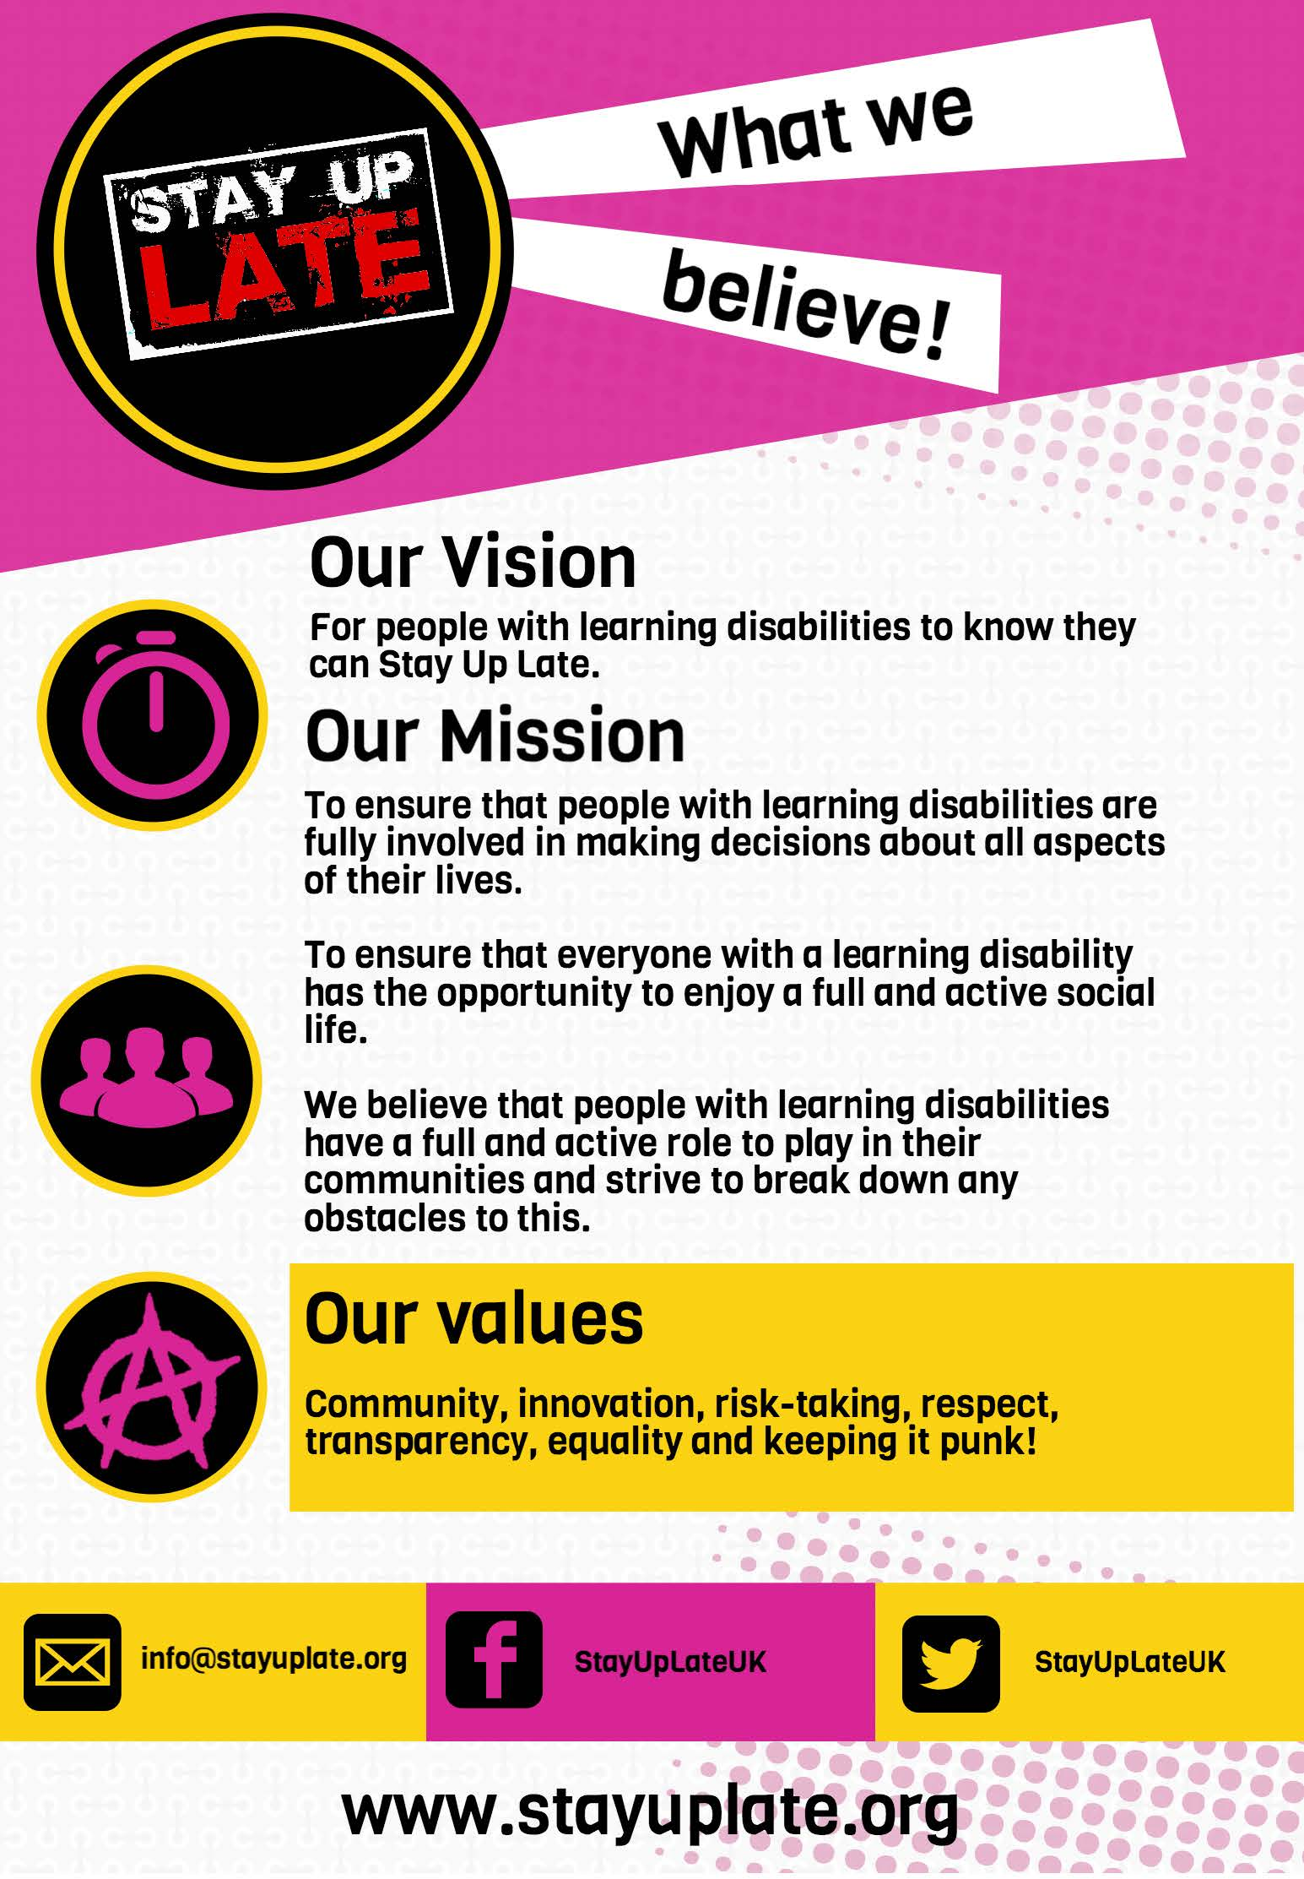

Stay Up Late Campaign Co-ordinator

You will be based in our office in central Brighton but there will be an element of travel in, and outside of, Sussex.

The post is for 22 hours per week (but one hour per day is a paid lunch break, so this amounts to 19 hours of work each week), the pattern is negotiable, and it will be necessary to work some evenings and weekends. (Sociable hours as we like to call them!)

The salary is £11,322 (pro rata) based on £18,870 per annum (NJC Spinal point 18), paid monthly in arrears. You will be paid on the last working day of the month.

25 days annual leave per year.

We also provide a pension scheme for qualifying staff.

Closing date for applications is 5pm on Thursday 8th Nov ‘18. Interviews will be held on Thursday 22nd November ‘18 in Brighton.

The start date will be week commencing 7th Jan ’19.

We will also be organising some flexible pre-induction evenings before Christmas where you can attend our social meet-ups to get a feel for the project.

How to apply

To apply please complete the application form (link on our website) and submit your 60 second video to tell us why you’d be great at the job and what makes your heart sing!

(Details of how to send the video to us are in the application form).

Please note that we can’t accept CVs.

JOB DESCRIPTION

JOB TITLE: Campaign Co-ordinator

ACCOUNTABLE TO: Director

OVERALL PURPOSE OF THE JOB

To support the Director in delivering and developing the Stay Up Late campaign across the UK.

Key Responsibilities

- Supporting people with a learning disability and/or autism to have a voice in calling for change in the way they are supported, and enabling them to lead full and active social lives.

- Ensuring that the campaign is as led by people with learning disabilities as possible. This will include facilitating campaigning groups and workshops.

- Creating and developing a national network of campaigning groups.

- Using online resources, as well traditional ones, to develop and motivate these networks. Creating a real movement for change.

- Project admin: including keeping accurate records of activities and producing reports and updates.

- Producing resources and materials in an easier to read format. You will also need to be prepared to use other media that’s best for people to get their views across. i.e. videos.

- Developing and publishing campaign resources (with the support of the Director).

- Organising events.

- Co-working with people with learning disabilities and supporting them in their work as campaigners.

- Providing training to people with learning disabilities who want to be local campaigners.

- Effectively telling stories of change and communicating our work to the wider world (this will be a key element of the job).

- Contributing relevant articles for our websites on a regular basis.

- Promoting the campaign to the wider community through networking and events, including running charity stalls.

- Promotion and marketing of our campaign resources and materials (both free and paid for).

- Linking in with the wider network of Gig Buddies partner organisations to develop their role as campaigning groups.

- Supporting the work of the Gig Buddies Sussex team in enabling participants with learning disabilities to be effective campaigners.

- Supporting the Storm and Thunder Team, and The Wild Rainbows (our advisory groups) to be engaged in our campaigning work.

- Supporting our fundraising efforts and the wider activities of the charity.

- Working as a team member, sharing skills, and contributing to the smooth running and good reputation of the charity.

- There may be a requirement for some occasional travel outside of Sussex for your work. (The charity will make suitable arrangements for your travel and any accommodation)

- Undertaking such other duties and tasks to fit with the wider work of the charity.

Closing date for applications is 5pm on Nov 9th and interviews will be held on 20th and 21st Nov ’18.

PERSON SPECIFICATION
Campaign Co-ordinator
 | Essential | Desirable
Skills and Abilities
Ability to problem solve independently and to remain calm in challenging situations.
Ability to communicate effectively with a wide range of people at all levels using a variety of methods, including a good telephone manner.
Ability to organise own workload, be able to work under pressure and to work to deadlines.
Able to communicate messages to different in clear and appropriate ways (e.g people with learning disabilities, social care professionals etc)
Able to think creatively

Knowledge / Experience
Experience of working with people with learning disabilities in an empowering, person-centred way, always treating people as individuals.
Experience of group facilitation, for example training or consultation.
Experience of supporting volunteers.
Experience of organising and promoting events.
Experience of using Microsoft office or similar software.
An understanding of the database system Salesforce.

Qualities
A positive attitude towards the rights, independence, inclusion and choice for people with learning disabilities.
Someone who is able to put their ideas, and other peoples’ ideas in to action
A keen interest, and skills, in promoting projects in line with current social media trends and practices.
Commitment to the values of diversity and equality and able to recognise and challenge disability discrimination in all its forms.
Someone who is able to work well as a team member, and has the attitude of supporting colleagues to get the work done.
Someone who can work independently out in the community and use their initiative.
Sensitive and a good listener.
A confident and positive person - willing to participate, get stuck in and have fun!
Able to effect change and influence people without confrontation.
Special Conditions
Flexibility regarding hours, including evenings and weekends

We also asked our advisory group, the Storm and Thunder Team, what is important to them in the right person. (The Storm and Thunder Team is made up of participants with learning disabilities).

 | Essential | Desirable
Skills and Abilities
Good at problem solving
Good at making our ideas happen
Good at finding creative ways to help us communicate
Being clear when making arrangements
Good at including people with learning disabilities meaningfully in volunteering in the office
Good at speaking in meetings
Knowledge / Experience
Experience of supporting people with learning disabilities
Good at IT and using computers
Qualities
Friendly
Organised
Flexible
Not phased by a bit of chaos
Good at time management
Someone who is good at taking part
A good sense of humour
Happy to dance – it doesn’t matter if you’re not a good dancer!
Loves music and going to gigs
Respectful and not judgemental
Has a ‘Let’s do it, let’s do it’ attitude

Campaign Co-ordinator – WHAT HAPPENS NEXT?

Successful interview

