About our conference

TUESDAY | On Tuesday the 26th March 2019, Stay Up Late is hosting an event.
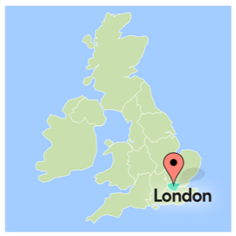 | It will take place in Streatham, London where we will cover our manifesto.
 | A manifesto is a list of things we are aiming towards achieving.
The manifesto lists 10 things that people with learning disabilities say they want in their lives.

We found this out through running workshops and speaking with people over several years.
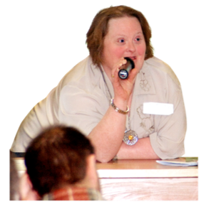 | We are looking for speakers to choose one of the manifesto points to cover during the day.  We want to hear positive stories about how people with learning disabilities making the points in the manifesto work in their own life.
 | The time for each point will be 15 minutes long.
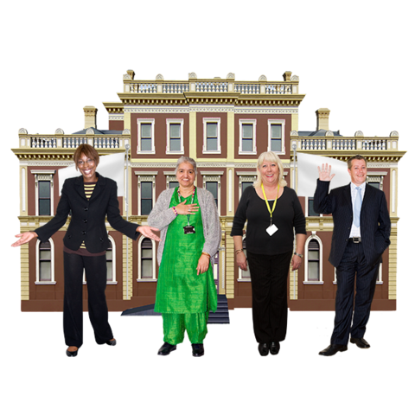 | The audience will be managers and other staff who work in social care.  Both people who work for support organisations and local councils.
The speaker can present their ideas in any way they want, such as by making a film or singing a song.

The topics we want people to talk about are:
- Recruiting my support staff, and choosing who supports me.
- Having happy support staff who love their work
- Having an active social life (and seeing my friends when I want to)
- Choosing where I live, and who I live with
- Choosing how I spend my time
- Choosing what time I go to bed, and when to go home from events.
- Having good relationships (including a love life)
- Being active and welcome in my community
- Having a proper paid job
- How I’ve challenged disability hate crime

 | The event will be from around 10am to 4pm.
 | But you will need to consider time for travelling and setting up.
Please fill in the application form provided.

You can find it at www.stayuplate.org

