Becoming a Stay Up Late Ambassador – what it involves

We are looking for people around the country who have a learning disability and/or autism who want to help us spread the word.

1. What does Stay Up Late do?

Stay Up Late is a charity for people with learning disabilities.

We started up the Gig Buddies project and we work with different Gig Buddies groups around the country.

We also do lots of campaigning!
- What does Stay Up Late stand for?

We want people to be able to make their own decisions about how they spend their time and when they go to bed. #NoBedtimes!

We put together our Manifesto for an Ordinary Life. It includes things like:

  - My right to decide how I spend my time and when I go to bed.
  - My right to fall in love and have relationships.
  - My right to a paid job.
  - My right to have a say in who supports me.
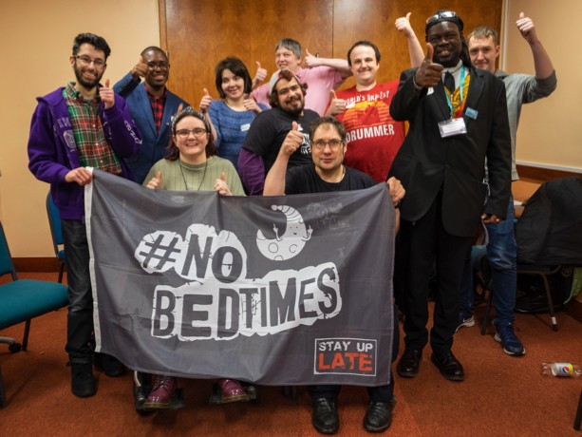 | 3. Who can become a Stay Up Late Ambassador?  Anyone with a learning disability and/or autism who supports what we stand for can get involved.  We work with different groups around the country to tell people about Stay Up Late and tell support providers why #NoBedtimes is important.

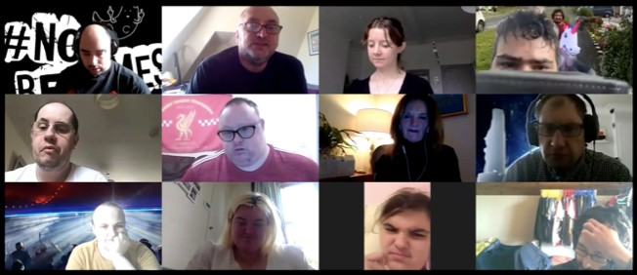 | 4. What does being an Ambassador involve?  Our Ambassadors do things like hand out flyers at gigs and take part in conferences.  We also have meetings once a month on Zoom.  Other things our Ambassadors do include:  - Write blogs for our website.  - Talk to people about Stay Up Late and encourage them to get involved.  - Go on the radio and TV and do interviews and videos.  - Help us create resources and raise awareness!  It’s up to you which things you choose to do!
- What help can I get to be an Ambassador?

  - We can help with ideas for a blog or a talk.
  - We can send you leaflets, posters and stickers.
  - You can get in touch if you have ideas for things you want to talk about.
  - All our Ambassadors support each other and help each other out!
6. Who can I get in touch with?

Florence is the Campaigns Co-ordinator at Stay Up Late. You can email her at florence@stayuplate.org
Or phone her for a chat on 07305 876 188

