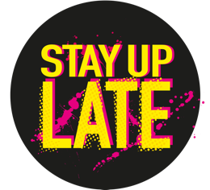

Ambassadors meeting – 23rd November ‘22

Hello and introductions
Daniel, Alice, Mark, Sophie, Florence, Fiffi, Rohan

We all said hello to Florence our new Campaigns Coordinator.

Mark has been recording a new song with The House of Deviants and vaguely autistic. We’re looking forward to hearing that.

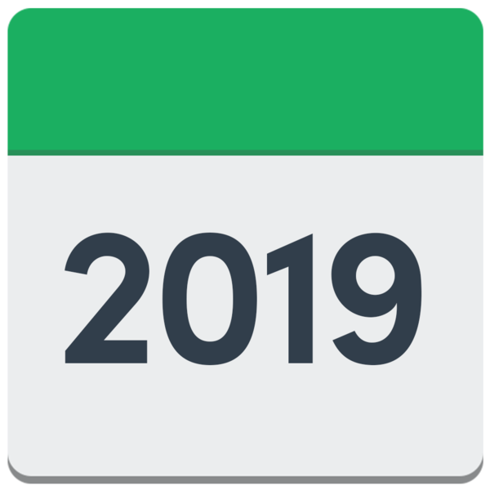  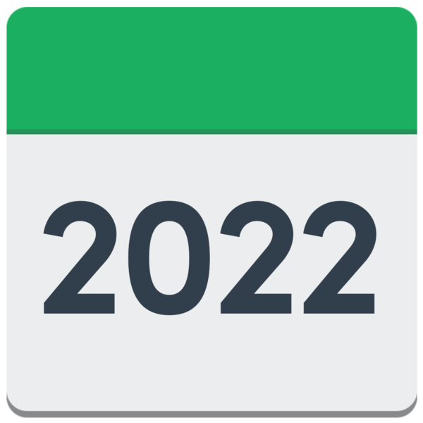  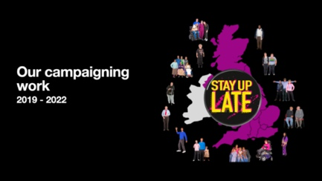 | Looking back at our campaigning work  Paul showed some slides looking back at our campaigning work for the last 3 years.  The main highlights were:  - The (un)Ordinary conference, March ‘19  - No Bedtimes campaign launch, Nov ‘19  - Ambassadors day, Brighton, Jan ‘20  - Starting our network on Zoom, April ‘20  - Disability Arts Online video, Dec ‘20  - Life After Lockdown blog, Feb ‘21  - The local authority letter, June ‘21  - Ambassadors day online, Oct ‘21  - Over 40 campaign ambassadors, Nov ‘22  - Campaign pledges launch, Feb ‘22  Plus lots of talks online, and in person and publishing our campaign resources.
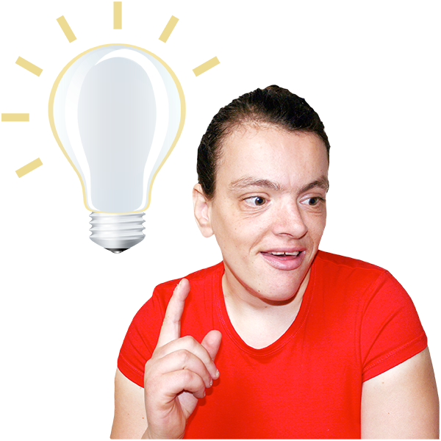 | Ideas for what we can do next  We talked about the ideas we had for what we can do next.
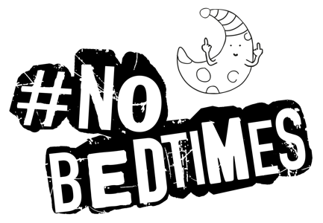 | Should we end the #NoBedtimes campaign as it’s getting old?  We thought that there is still a lot of work to be done around peoples’ social lives.  We shouldn’t stop #NoBedtimes as a campaign but we should think about doing something different.
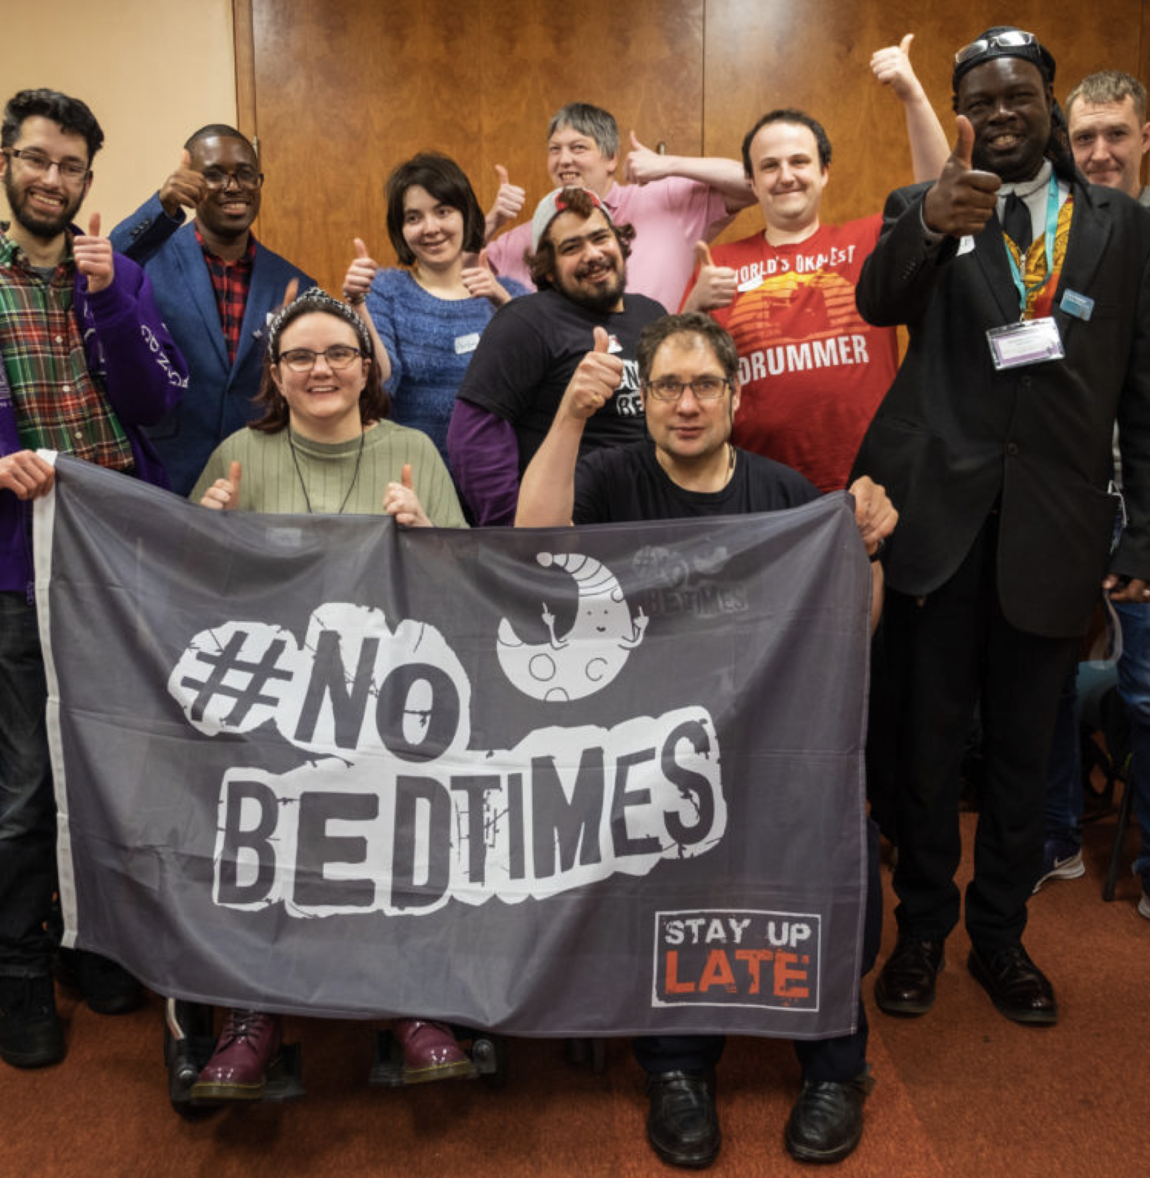 | Ambassadors day  It would be good to have another Ambassadors Day.  Daniel said Birmingham would be good.  Paul thought we might be able to find a cheaper space to hire in Brighton.  Paul said we need to find a cheap way for people to stay overnight.
Having more events
We talked about holding more events but some of us said we would also need to think about being safe because of Covid.

These could be workshops where we could make banners and bunting about the campaign.

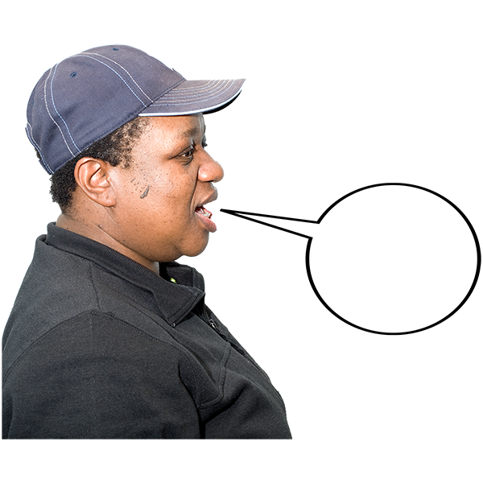 | Telling stories  We talked about different ways in which we could talk more about No Bedtimes.  We liked the idea of asking Lucy (a Gig Buddy in Eastbourne) if she could write another cartoon for us.  Paul also said Ned in Burgess Hill has done great work for us in the past.  We thought this is a good way to get people interested.
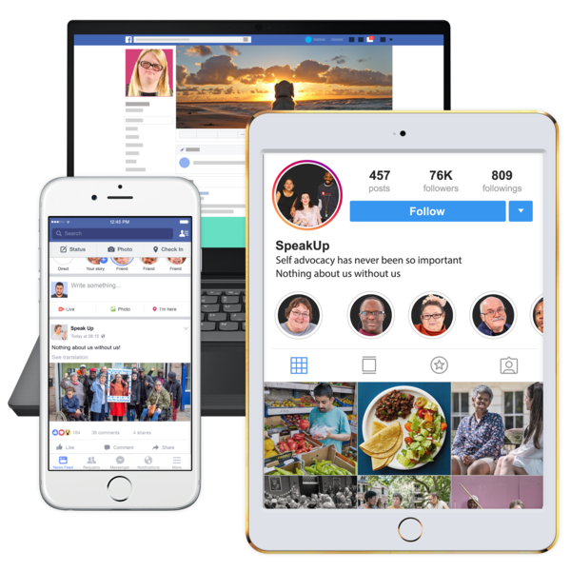 | Using social media to reach more people  Florence said there’s all sorts of ways to get people more involved through our social media.  We can make short videos about all sorts of bits of our work.  We can send out ‘polls’ which are a great way of getting people involved too.
Newsletters
We could send regular newsletters to all the campaigners about what we’ve been up to and also to the wider world.

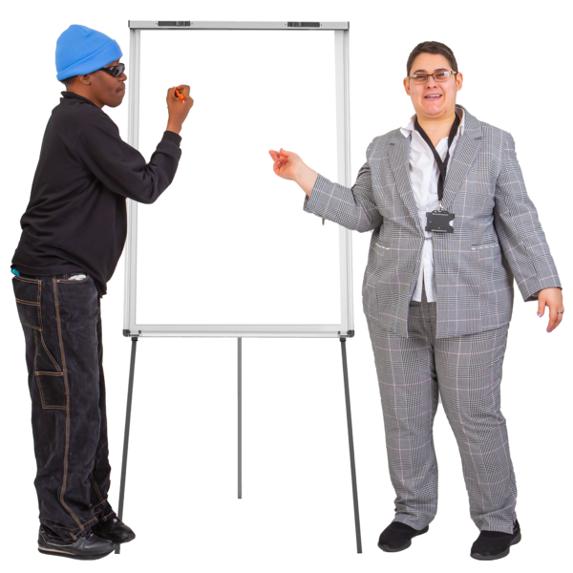 | Training  We could hold workshops or webinars on how to be a campaigner.  We could write a training course for staff and turn this into a resource we can share.
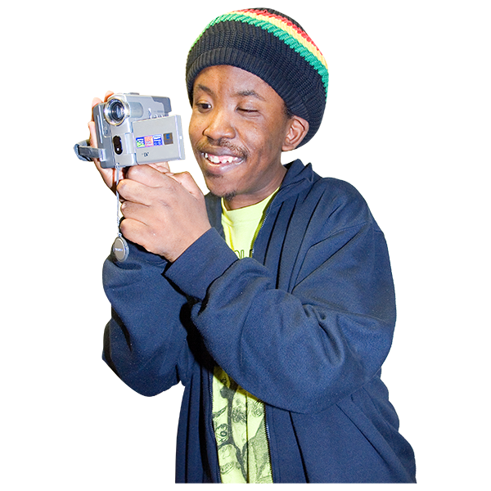  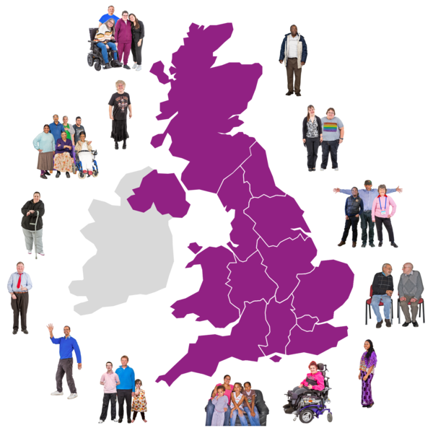 | Getting more ambassadors involved  We thought we could make videos about  ‘how do you become a campaign ambassador?’  Or  ‘what a campaign ambassador does’  We said it would be good to get all the ambassadors more involved and train them to campaign in their local areas.  We could also get support staff involved as ambassadors too.
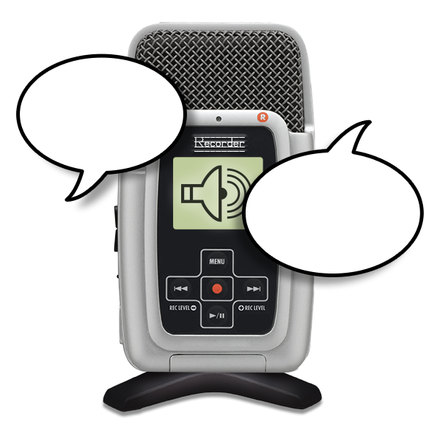 | Podcasts  We could use the new Stay Up Late podcast as a way for ambassadors to talk about different issues around the No Bedtimes campaign.  Daniel said it would be good to get back in touch with Neil Crowther from Social Care Future as we got interrupted last time we spoke with him.
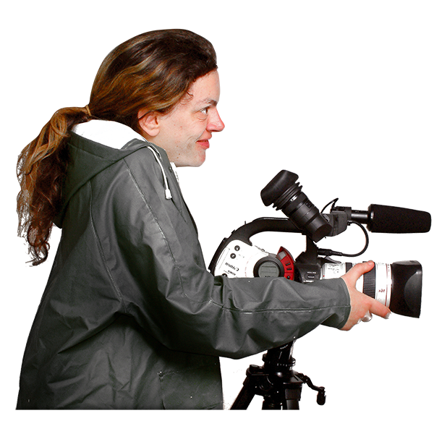 | Videos  Other ideas for videos were:  - A video talking about why we don’t think club nights that start at 5pm are a good thing.  - Or funny videos of us being bored or having to go home early from a night out.
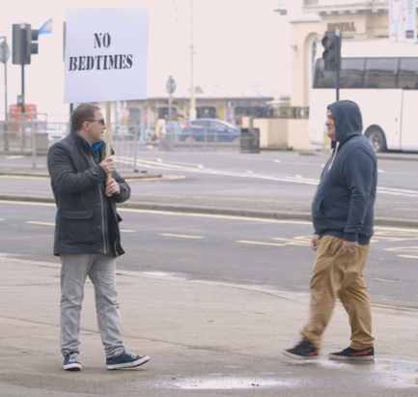 | Looking back at old stuff we’ve created  Paul said we have quite a few things like videos that we’ve made in the past that we can reshare and make more use of.
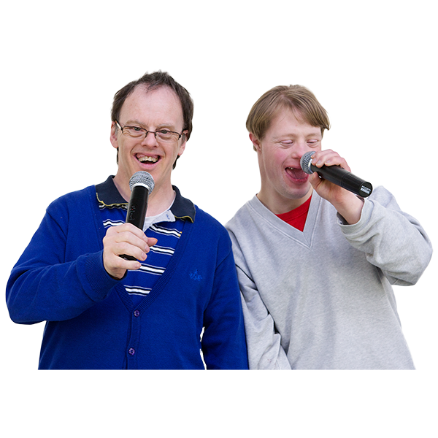 | No sleep ‘till bedtime song  Paul has just received the latest version of this from Steve at Bemix and will share with everyone.
Using the ‘serious fun’ motto
Finding fun ways to raise awareness about our work and
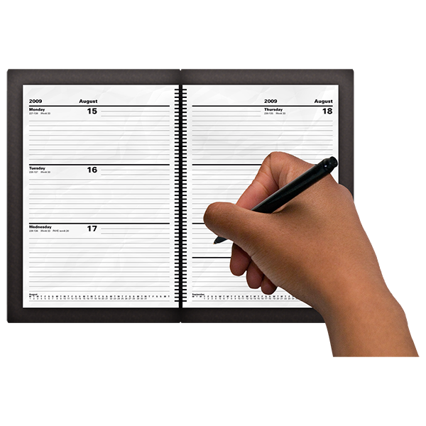 | Date of next meeting  Wednesday 11th Jan ’23 at 6pm  In this meeting we will talk more about all these ideas and work out what we can do first.

