Ambassadors meeting – 19th October ‘22
6pm to 7pm

Present
Phil and Alison, Bridgewater
Alice, Bedford
Mark, Port Talbot
Rohan, Hove
Sophie, Tenby
Daniel, Hastings
Shannara, Crowborough
John, Highlands
Paul, Hove

Our news
Sophie won a Community Connectors award through Mencap and went to an awards ceremony in Cardiff. Big congratulations.

Daniel has been nominated for a Learning Disability Leaders Award.

Shannara said that Jay from Repair Shop, Ian Wright and John Bishop have all been talking about different support issues they have had in their lives.

Phil has been awarded £700 funding for his next film for ‘Same Differences’ on Youtube. It will be about finding it hard to find paid work.

The rise of 5pm club nights
We watched the video from the BBC’s website about a ‘club night’ that has started up which starts at 5pm.

This is a link to the video:
https://www.bbc.co.uk/news/av/uk-england-gloucestershire-63177165

We talked about what was good about events like this and what we didn’t like.
What we liked about the video
It looked like it was a safe place where people could meet their friends.

This means you can see your friends, make new friends and have a dance.

What we didn’t like about the video
We didn’t think it was really ‘inclusion’ as it didn’t look like it was open to the general public.

We thought it looked more like people with learning disabilities were being ‘contained’.

In the video they said people with learning disabilities didn’t “feel safe” in regular night clubs. We thought this was really bad.
The answer is not to segregate people though.
This is something the council and the police should be looking in to.

Paul said he saw another event happening near him that was from 5pm to 7pm.
What are the things that need change?
It’s nice to be able to do things like this but not if it’s the only thing you can do like this. Why can’t people stay out late?

People with learning disabilities should feel safe to go out late at night.
They should also be supported to go out late at night.

It would be better if it started later as 5pm is an early time to start dancing, especially if you want to stay up late.

You should be able to go home when you want to.

It needs to be clear that people have choice about going to regular club nights too and deciding what time to go to bed.

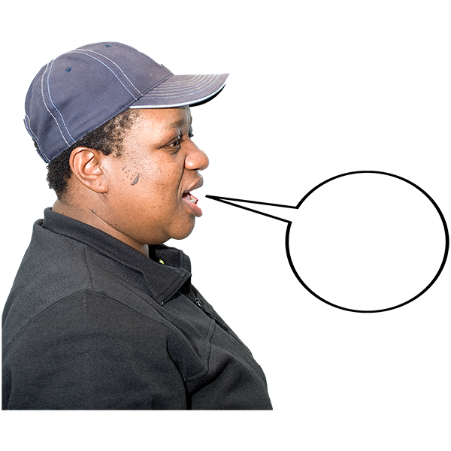 | What we said  “We are told that support workers need to get home early in case there is a medical emergency.” Shannara  “I have to leave events by 9pm as I’m told to be home by 10pm. This is a curfew.” Shannara  “It’s not a night club. A night club us a nighttime thing.” Alice  “This is a new phase.” Shannara  “This is happening a lot and people are getting excluded”. John  “8.30pm is not a time to go home. And what we’re asking for is not all the time.” John  “Let people have a proper night out”. John  “I wonder if they get a doner kebab on the way home?” Paul  “Or a pizza!” Sophie  “It feels like they’re patting people on the head and treating them like children”. Paul  “They’re ticking a box to say they’ve done that.” Rohan  “I went clubbing until 3am with my gig buddy.” Shannara
The cost of living crisis
We talked about the fear that the press are creating about the cost of living crisis.

Everyone said it is making them worry but we don’t really know what it means.

We agreed it would be good to have some clear and accessible information about the cost of living crisis.

It would also be good to have some practical money saving tips.

Paul said Learning Disability England have been collecting some resources and he will share these.
We thought that there could be a big impact on places like churches and community centres because of their increased heating costs.
This could end up making more people even more isolated.

Podcast idea
Paul talked about the idea of starting up a podcast to talk about some of the issues.

Everyone thought this sounded like a good idea and would be good to get different people talking on it.

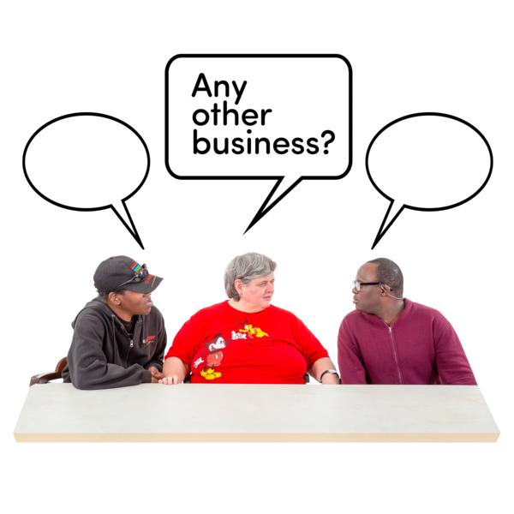 | Other business  John is hosting Zoom parties and will send the link to Paul so he can share it with everyone.  DJ Chris Love is staging a party in Hove on Saturday, all are welcome. It’s at Hove Methodist Church.  We talked about getting our seasonal vaccine boosters booked in. We agreed it’s good to remember to do this.
Date of next meeting
Wednesday 23rd November at 6pm on Zoom.

