Ambassadors meeting – 7th September ‘22
6pm to 6.45pm

Present
David, Sharon, Sophie, Daniel, Alice and Paul

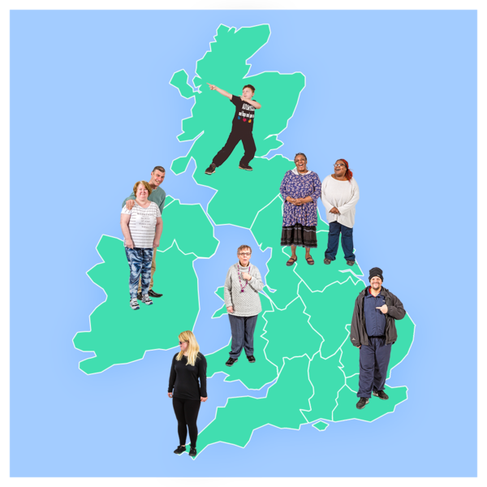  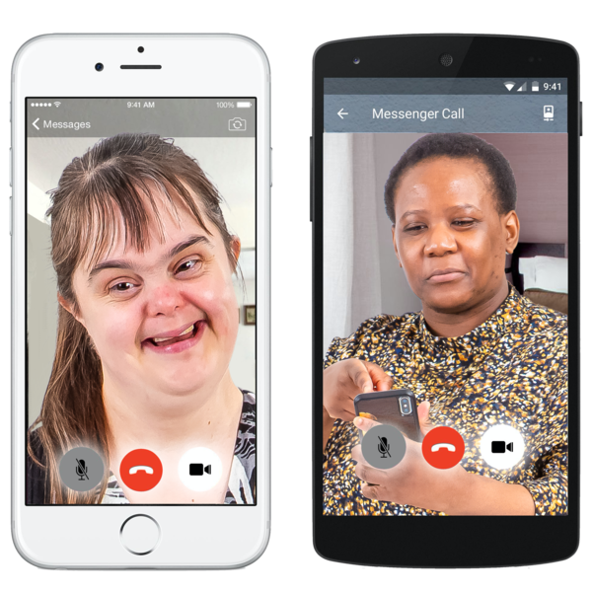 | Developing our campaign network  We thought we needed to do something different to ‘No Bedtimes’. We think it’s still a very important issue but people might have become tired of it.  We said we need to try and freshen things up.  We talked about ways in which we could do this:  - We could make some short videos with ambassadors saying what they are doing or why staying up late is important to them.  - We could have peoples’ Stay Up Late stories – saying where they’re from and one thing about why it’s an important issue.  - We could invite a guest speaker from a support provider. (David suggested Lisa French from Innovate Trust).
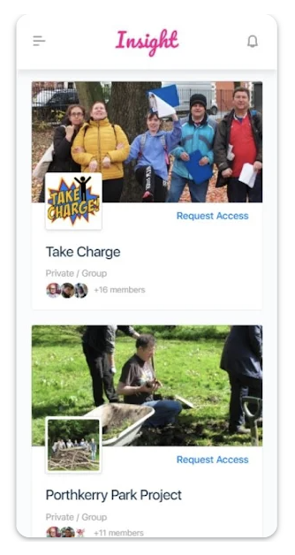 | David asked why these meetings aren’t taking place through the Innovate Trust app called Insight.  Paul doesn’t know why we’re not doing that but will look into it for the next meeting.  We could see if we can create a closed group on there for the ambassadors. We can still hold the meetings on Zoom.
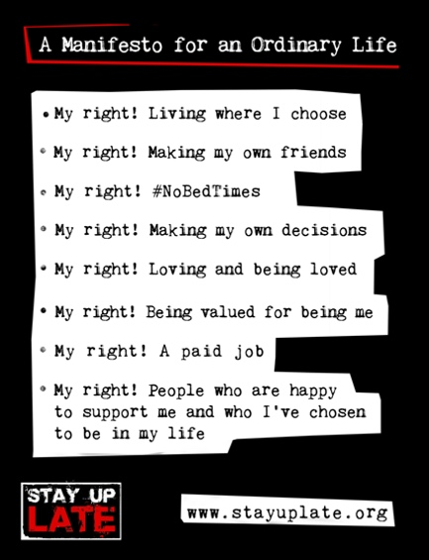 | Stay Up Late staff awards  Paul spoke about his idea for an award for great support staff to help celebrate the work that they do.  There wouldn’t be any big ceremony, it would all be online and wouldn’t need to cost too much.  The group thought it was a good idea and that we should keep it nice and simple.  We thought we could make the award categories link to our Manifesto for an Ordinary Life.  We talked about making the award something that doesn’t last so people don’t get lazy and think they can’t still do even better.  Ideas for this were:  - A candle  - A bunch of flowers  - Fireworks  - A cake – we all really liked Nicole’s idea of a cake.  We also thought it was probably safer to post a cake than a rocket through the Royal Mail!
We talked about the work that support workers do and Paul talked about an article which he recently posted online which has gone down well.

Here’s the link:
https://medium.com/@paulrichards_75021/the-six-types-of-support-worker-b2b3653c7089

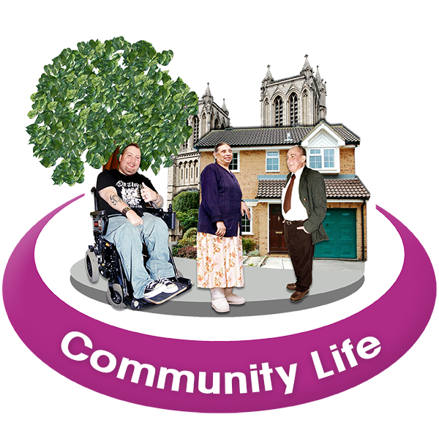 | We talked about training that we could create for support workers.  One thing we could train them in is thinking about how to connect people into their communities.  Another session was training staff on how to support people after the lockdowns have ended by while Covid is still around.
 | Dan said he is planning a sponsored walk for Stay Up Late. He plans to walk from Hastings Old Town to the pier and back again.
Keeping updated
Paul asked what was the best way to send updates about the ambassadors network.
Everyone said by email is best.

Campaign resources
We talked about ways in which we could support the work of the campaign ambassadors more and our ideas were:

Asking people to talk in their residents’ meetings and finding out what they’d like to change locally.

We said we want to grow a bigger network of ambassadors. We thought we could make a new leaflet to help do this.
Future meetings
We decided that we would meet every 2 months.

Paul will send out the link to the next meeting which will be on 19th October at 6pm.

