Strategy 2019 -2023

This is our plan for the work we want to do in the next 4 years.

All of these plans fit our overall vision as a charity.

Our vision is:

That learning disabled people and people with autism should live the lives they want.
We believe they should be included within all aspects of society and their communities.

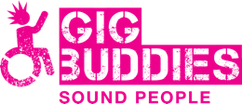 | We do this mostly through our campaigning work and through our Gig Buddies project.
Our strategy has 4 main aims:
- Campaigning
- Our projects
- Sustainability
- Our people

- Campaigning to end inflexible support that means people can’t live the lives they want
We will do this by:
- Developing a network of campaign ambassadors
- Raising awareness across social care
- Talking with commissioners in local authorities
- Doing more online campaigning
- Support people with learning disabilities to lead research on issues that affect them

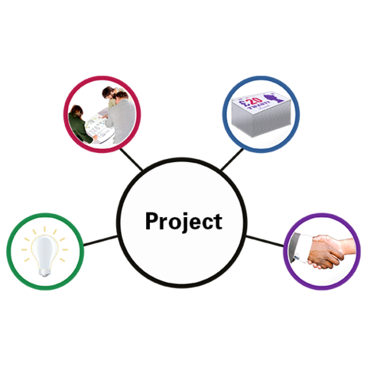 | - Our projects. The things that we do that enable us to deliver our vision as a charity  We will do this by:  - Continuing to run Gig Buddies in Sussex and showing how it makes a real difference to peoples’ lives  - Support more organisations to run Gig Buddies projects and make sure we do that well  - Look at whether we can develop our idea for a virtual reality video project
- Being sustainable. This means making sure we have a good plan to keep the charity going.
We will do this by:
- Looking at new ways to raise funds that involve links with businesses
- Working with a fundraising expert
- Have a good plan for writing fundraising bids
- Look at things that we could sell to other organisations such as training course
- Find a good way to collect information that shows how we’re doing a good job
- Our people.
This is to make sure we have a happy staff team where everyone shares the same aims.

We will do this by:
- Making sure we have a healthy team who are well supported
- Look at ways in which we can build on the skills we already have
- Making sure our office is a happy and healthy place to work
- Asking our trustees what skills they have and finding new people who have the skills we need
- Develop the way we support people with learning disabilities to be our trustees
- Work on making sure we communicate well across the team as our team and work grows
- Have a good plan for what to do if key members of staff decide to leave

