NOTES FROM STORM AND THUNDER MEETING 4/02/21

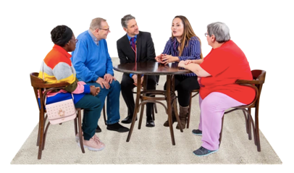 | Who was there: Rami, Fran, Bethan, Rohan, Chris L, Chloe, Lowri, Annie and Gary
We checked in with everyone and introduced ourselves.

We met Gary who told us all about his job and what he will be doing for Gig Buddies
- Gary previously designed the Gig Buddies logo but now we want something new to demonstrate the word ‘connection’
- The key word to think about is ‘gig’- this used to relate to going to live shows, but has the meaning changed now? This was something to think about throughout the session
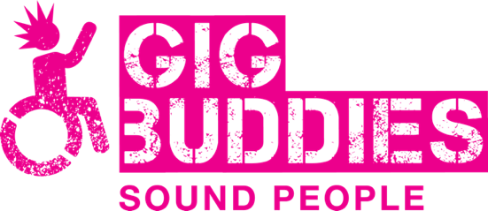 | What does Gig Buddies mean to you?  - Fran loves going out to gigs and it makes her feel happy  - Chloe loves Gig Buddies because it means she can go out. Chloe explained that beforehand she usually feels nervous about going out, but after it makes her feel like she’s really achieved something.  - Rami likes going out and having someone to talk to. He also likes going to the Gig Buddies socials as a group.  Everyone agreed that Gig Buddies was about connection
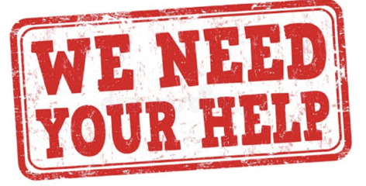 | We looked at both the Gig Buddies logo and the Stay Up Late logo. What do you like and dislike about the current logo?  - Rami doesn’t like the colour and thinks the font is unclear. Especially the ‘B’ which looks like a 3.  - Chloe thinks there should be some red in there. This would also fit in with the Stay Up Late logo  - Chris likes logo but thinks it should be purple  - The group agreed that the colour should change
What do we think about the wheelchair? Does it represent Gig Buddies?

- At first everyone agreed that they liked the wheelchair graphic. However, as the conversation continued people discussed that perhaps it isn’t representative of everyone.
- Bethan raised the point that there could be several different people in the logo
- Fran said there could be someone with a walking stick
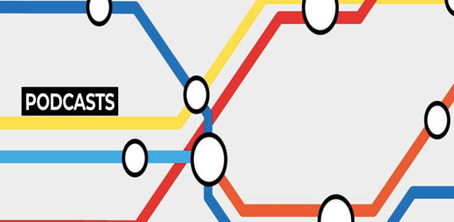 | We looked at some of Gary’s other work which represented the message ‘connection’ despite having no figures in the graphic.  - Can we represent the word ‘connection’ in a different way?  - Chloe thinks we should include a message about the LGBTQ+ community  - Chris had previously said he liked the hands in the air moving graphic on the Gig Buddies website. Could we use something like this in the logo?  - Lowri explained that we want to find a way to show the world of Stay Up Late and Gig Buddies. Stay Up Late is the main umbrella and underneath that is Gig Buddies, Quality Team, Ambassadors, Advisory Groups.
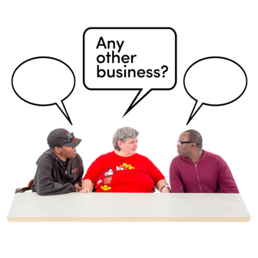 | Chloe showed us a design she had been drawing throughout. It was a big speech bubble which said ‘Gig Buddies, Stay Connected’ in the middle.  We have agreed to meet back up on Tuesday the 16th with Gary to finalise our ideas. In the meantime, the group will think about the logo and sketch some ideas down.

