Storm and Thunder Meeting 16/02/21

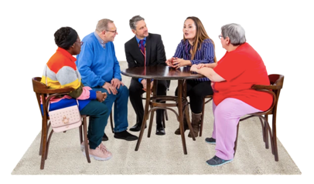 | Who was there: Rami, Fran, Bethan, Chris L, Chloe, Lowri, Annie and Gary
 | We checked in and discussed the notes from the last meeting.
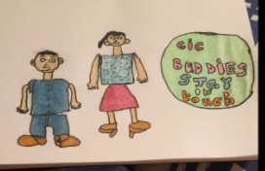  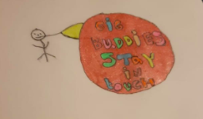 | We had a look at the amazing drawings and ideas that Chloe came up with  Where did the idea come from?  - Two people standing because we aren’t all in wheelchairs  - Wanted to show connection  - Created the strapline ‘Stay In Touch’ because this is important during the lockdown but also for life after covid  We all discussed our thoughts on the images  - Everyone loves the use of colour  - Rami likes the colours of green in the first image because it’s softer and calmer  - Bethan thinks we should add some musical notes  - Fran thinks it looks great and likes the fact it’s fun  - Gary likes the 2 characters that are shown
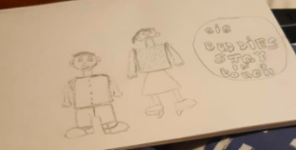 | We discussed how some logos for charities can look quite serious and we would like the Gig Buddies ones to be fun.  How can we do this?  - Fran likes how the Carousel logo has 4 different colours which represent different parts of the organisation  - We discussed how this could be an idea for showing the different parts of our charity: Gig Buddies, the quality team, ambassadors and the advisory groups  - Everyone agreed they would like more colour  Gary also explained how we need to be mindful that this logo will be going on the websites, t-shirts, leaflets etc so we don’t want it to be too complicated.
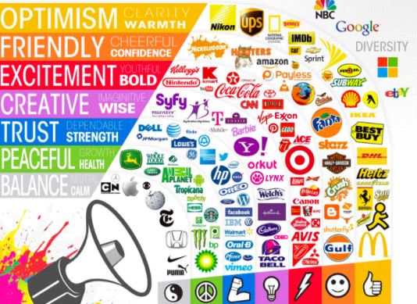 | Gary then talked us through colour theory and how this may help us decide on what colours we use.  We thought about what message we want to get across.  - Blue is for trust, secure, dependable  - Purple shows creativity  - Green shows feeling calm, the environment, growth  - Yellow is for positivity  - Red is energetic, exciting and bold.  If anyone has any more thoughts on colour ideas or straplines they will message Annie.

