Stay Up Late Glasgow Gig
and We Are One Festival

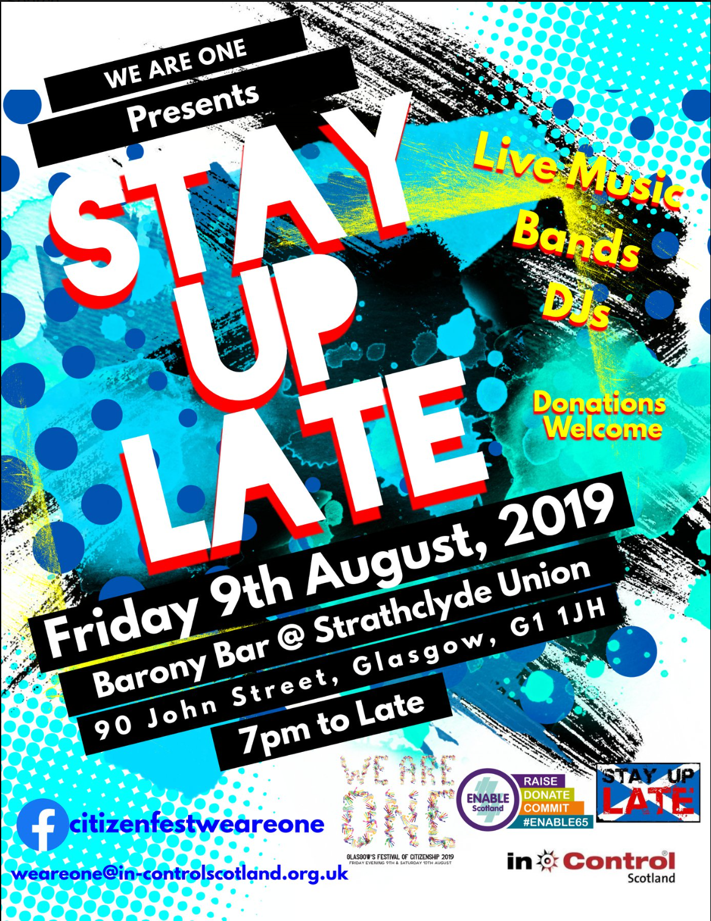

When is it?

Friday 9th and Saturday 10th of August 2019

The gig starts at 7pm on Friday.

What are the travel arrangements?

For people coming down from the North East, I (Alastair) will be going down and back on the bus as detailed below. I am happy to meet people at Aberdeen Bus Station on the Friday go down on the bus together and be a contact and help people attend, getting to the venue etc. and be around on the Saturday and the return journey. My number is 07388 397074 and my email is alastairminty@gmail.com

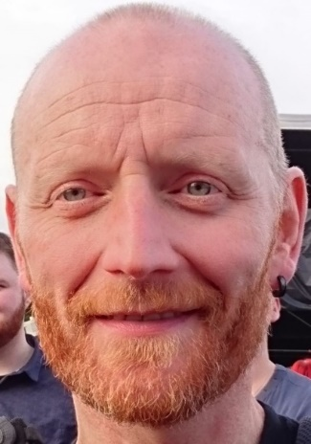
I am happy for these contact details to be shared with people attending, but would appreciate it if you can help ensure you share the main answers covered here, so I don't get loads of repeat queries about bus times etc.

For anyone who doesn’t know me, this is
who you are looking for at the bus station.

I am only one person, and so if anyone has significant support needs, the support provider would be responsible for providing that support. (I don’t mind helping with anyone with their money or reminders to take medication etc, as long as I know (see the info section on the next page).

If you can be there for 1pm on Friday with your bus ticket, that
would be great, we plan to go down on the Citylink Gold bus on Friday - leaving Aberdeen 1.15pm and returning on the Citylink Gold bus from Buchanan Street Glasgow at 5.10pm on the Saturday.

For anyone driving, if you have a blue badge you can access the parking via Rottenrow. If you have a car but no blue badge the University have a scheme where they have a reduced rate of £5 a day at a local car park. If you want this, let June know when you book accommodation.

What we need you to do -
- Spread the word to people who may be interested, it is open to everyone
- Book the accommodation through June Dunlop from In Control has accommodation booked at Garnett Hall, Strathclyde University. Rooms cost £27 per person. Everyone would have their own room with a sink, and the living room, kitchen and bathroom are shared between 6 rooms. The accommodation would only be used by people booking for the Stay Up Late event through June, not the general public. The same rate is payable for rooms for support staff. This is a link to the website so you can see what the rooms are like - https://www.strath.ac.uk/campustour/#

If you are an active member of the Learning Disability Group of Aberdeen and Aberdeenshire, the group intends to settle their booking as a whole, everyone else should pay June individually. If you need a wheelchair accessible room contact June on the details above. There are separate en-suite rooms with accessible bathrooms, these cost a bit more, and are based in another building (more info available after the 18th when a site visit is planned).
june.d@in-controlscotland.org.uk Tel 0141 440 5250
- I need people involved to help anyone going to book their own bus tickets in advance, and get to the Aberdeen Bus Station on the Friday, (and get home from Aberdeen bus station on the Saturday night)
- There is no need to book tickets to the gig, we just turn up!
Info –

With quite a few people going down together it would be helpful if I can be emailed the following info –

Name
Mobile number
Emergency contact
What will it take for me to have a good time? (anything important I need to know about to make the trip a success for everyone)

Bus booked
Accommodation booked

(I will delete all this info after the trip)

Costs -

There is no fixed price for the gig, you can make a donation on the door, so the only costs are food and drink and bus fares in Glasgow if you don’t have a bus pass.

Timings on Friday –

After arriving at Buchanan Street, we will take the bus to Garnett Hall Strahclyde University and relax for a while, get something to eat close by around 5pm, and head along to the gig for 7pm. The gig finishes at 11.30pm (ish) some people may want to head off at the end or before that, some may want to head out somewhere else after, it’s up to you. I will be able to head out with anyone staying out for a bit. We will have people with mixed levels of mobility so walking will be kept to a minimum.

Saturday –

We Are One Citizen fest

A load of workshops, music, discussions etc in venues across the middle of Glasgow. More details nearer the time, you can go to lots or none, it’s up to you.

I will be involved in running two workshops on the Saturday – one called people-based development about how we can get more active inclusive communities, and one with Amanda Ashton Booth on ROAR about peer support for people leaving care. I have asked for my workshops to be at the same place or close to each other, but that hasn’t been confirmed yet.

You can come to these workshops with me, or go to some of the others (or just look round shops or the parks) if you are confident getting around in Glasgow.

We will leave around 4.30pm by bus to get to Buchanan Street. Bus leaves at 5.10pm, back to Aberdeen for 8.10pm. As I said if people need support to get home from the bus station, please arrange for this to happen.

Anything I haven’t covered please ask.

Thanks, from Alastair and the rest of the Stay Up Late Scotland Team
