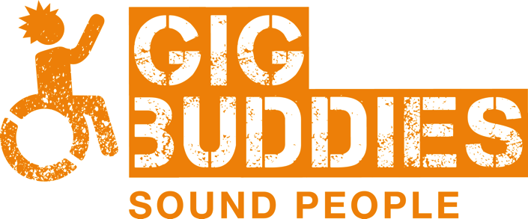

Gig Buddies

Project Assistant

Information Pack

GENERAL INFORMATION
Stay Up Late was started as an awareness raising campaign by the band Heavy Load in 2006 and featured in the feature documentary film (also called Heavy Load and incidentally one of Mark Kermode’s top 5 documentaries of the 21st Century!). Heavy Load were concerned at the amount of people with learning disabilities missing out on gigs due to their support staff working inflexible shift patterns.

The exposure of the film enabled the campaign to reach a wide audience of people experiencing the same frustrations. Heavy Load didn’t want their work simply to be about raising awareness and in 2011 Stay Up Late became a registered charity committed to also bringing about real change.
Our aim is to promote full and active social lives for people with learning disabilities.

The geographical location of our work is predominantly in Brighton and Hove and East and West Sussex. However, Gig Buddies has now been replicated in Sydney, Australia and in Scotland and we are in the process of helping some other organisations to run Gig Buddies in different parts of the UK. We continue to have a high profile nationally for the campaigning side of the charities work.
All of our income is derived from fundraising, and we rely on our well-established community links to achieve this.

Although the charity is still growing, we have a strong commitment to developing innovative projects that will enable people with learning disabilities to enjoy full and active social lives, and involve people with learning disabilities in the design, delivery and development of these projects.
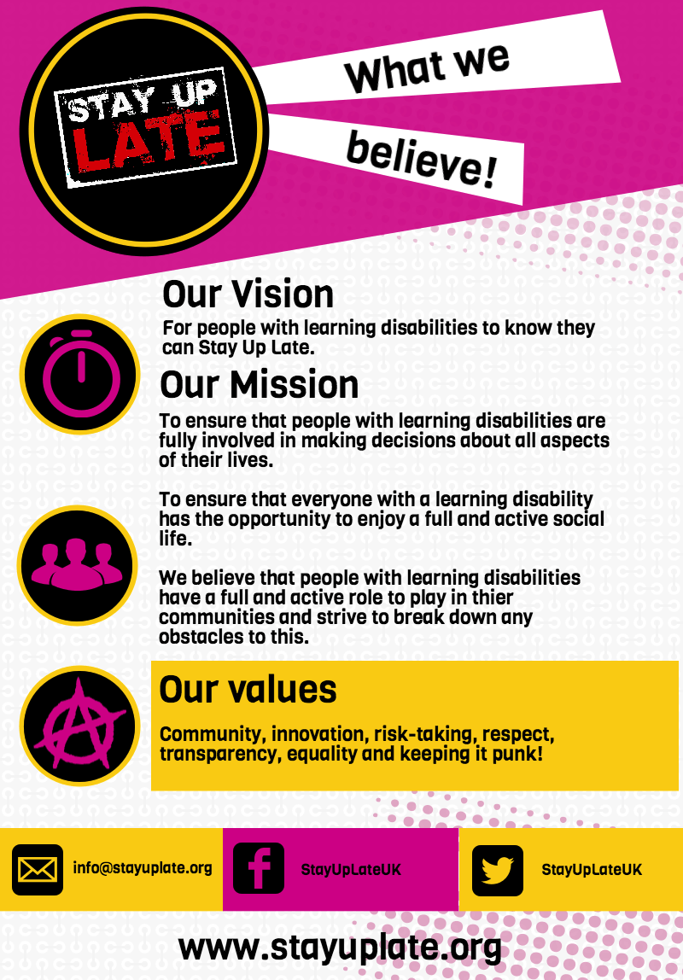

Gig Buddies Project Assistant

Attached is a job description for the post of Project Assistant.

This is a permanent post.

The post is for 40 hours per week (but one hour per day is a paid lunch break, so this amounts to 35 hours of work each week), the pattern is negotiable, and it will be necessary to work some evenings and weekends. (Sociable hours as we like to call them!)

The salary is £18,560 per annum (NJC Spinal point 19), paid monthly in arrears. You will be paid on the last working day of the month.

25 days annual leave per year.

Closing date for applications is midday on Monday 12th December and interviews will be held on Friday 16th December

To apply please complete the application form (link on our website) and submit your 60 second video to tell us why you’d be great at the job and what makes your heart sing!

(Details of how to send the video to us are in the application form).

JOB DESCRIPTION

JOB TITLE: Gig Buddies Project Assistant

ACCOUNTABLE TO: Gig Buddies Project Manager

OVERALL PURPOSE OF THE JOB

To support the Project Manager in delivering and developing the Gig Buddies project across Sussex. There will also be an element of supporting the wider work of the charity.

Key Responsibilities

- Supporting people with a learning disability and / or autism who use the Gig Buddies project.

- Ensuring that Gig Buddies is as user led as possible. This will include facilitating our advisory group meetings, supporting our paid Quality Checker and enabling participants of Gig Buddies to have meaningful roles helping to run the project.

- Project administration, including accurate record keeping, processing DBS checks for volunteers, project monitoring, taking up references and keeping our databases organised.

- Supporting volunteers, including conducting supervisions, helping to mediate relationships between gig buddies when there are issues, interviewing new volunteers and ensuring that volunteers feel valued.

- Organising events such as Gig Buddies socials, volunteer induction days and trustees meetings.

- Facilitating training, including volunteer induction days and other training as necessary.

- Communicating appropriately with a wide variety of stakeholders, including people with learning disabilities, support staff, carers, volunteers, funders, community representatives, members of the voluntary, statutory and private sectors.

- Speaking publicly about our work at conferences and other events.

- Promoting the project through social media, the press and the internet to users, relevant stakeholders and the community at large.

- Contributing relevant articles for our websites.

- Promoting the project to the community through networking and events, including running charity stalls.

- Supporting our fundraising efforts and the wider activities of the charity.

- Working as a team member, sharing skills, and contributing to the smooth running and good reputation of the charity.

- There may be a requirement for some occasional travel outside of Sussex for your work. The charity will make suitable arrangements for your travel and any accommodation).

- Undertaking such other duties and tasks commensurate to the character of work. Therefore the above list of main tasks in this job description should not be regarded as exclusive or exhaustive.

Closing date for applications is midday on Monday 12th December and interviews will be held on Friday 16th December

PERSON SPECIFICATION
Project Assistant
 | Essential | Desirable
Skills and Abilities
Ability to problem solve independently and to remain calm in challenging situations.
Ability to communicate effectively with a wide range of people at all levels using a variety of methods, including a good telephone manner.
Ability to organise own workload, be able to work under pressure and to work to deadlines.

Knowledge / Experience
Experience of working with people with learning disabilities in an empowering, person-centred way, always treating people as individuals.
Experience of group facilitation, for example training or consultation.
Experience of supporting volunteers.
Experience of organising and promoting events.
Experience of administration and knowledge of Microsoft office or similar software.

Qualities
A positive attitude towards the rights, independence, inclusion and choice for people with learning disabilities.
A keen interest, and skills, in promoting projects in line with current social media trends and practices.
Commitment to the values of diversity and equality and able to recognise and challenge disability discrimination in all its forms.
Someone who is able to work well as a team member, and has the attitude of supporting colleagues to get the work done.
Sensitive and a good listener.
A confident and positive person - willing to participate, get stuck in and have fun!
Special Conditions
Flexibility regarding hours, including evenings and weekends

We also asked our advisory group, the Storm and Thunder Team, what is important to them in the right person. (The Storm and Thunder Team is made up of participants with learning disabilities).

 | Essential | Desirable
Skills and Abilities
Good at problem solving
Good at making our ideas happen
Good at finding creative ways to help us communicate
Being clear when making arrangements
Good at including people with learning disabilities meaningfully in volunteering in the office
Good at speaking in meetings
Knowledge / Experience
Experience of supporting people with learning disabilities
Good at IT and using computers
Qualities
Friendly
Organised
Flexible
Not phased by a bit of chaos
Good at time management
Someone who is good at taking part
A good sense of humour
Happy to dance – it doesn’t matter if you’re not a good dancer!
Loves music and going to gigs
Respectful and not judgemental
Has a ‘Let’s do it, let’s do it’ attitude

Project Assistant – WHAT HAPPENS NEXT?

Successful interview

