Quality Checker for Stay Up Late

Job advert

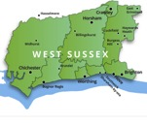 |  | To qualify for this job you need to have a learning disability and live in West Sussex.
Hours
8 hours per week
(1 hour of this is a break)
Wage
£8.25 per hour

This is what the job would involve:

Consultancy
You will feedback to the Gig Buddies project coordinators about your experience of the project and how we can improve it.
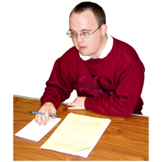 | Checking the quality of gig buddies  You will talk to gig buddies about whether they are happy with their volunteer, and what the volunteer could do to improve.
Research
You will interview gig buddies about how they find the project.

You will also interview support providers for the Stay Up Late campaign.
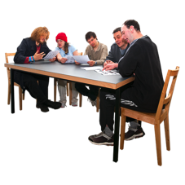 | Organise a team of volunteer researchers  You will also help to lead and organise a team of volunteer researchers who will be doing a similar role as volunteers.
Training
You will help to train new volunteers.

Volunteer recruitment
You will interview some new volunteers to see if they would be suitable buddies.
Social media
You will help to manage our twitter and facebook.
Promotion
You will be going to events to talk to people about the gig buddies project.
Office work

Occasionally the job will involve some admin.

You will send letters to people, stuff envelopes, post letters etc and help to keep our address lists up to date.
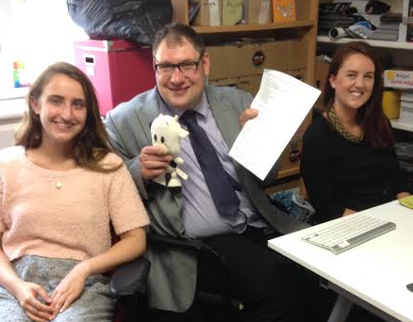
The Stay Up Late office

These are the skills and qualities that you will need to show you have to get the job:
Good listener
You need to be able to listen to what people are saying and help people to get their point across.
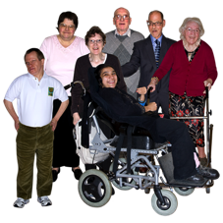 | Able to communicate with different people  You need to be able to listen and communicate with people who have different support needs.
Good at interviewing
You need to be able to ask questions and find out things about people.
Computer skills
You need to have basic skills with using the internet and social media (eg facebook) or be willing to learn.
Campaigning
You will need to be committed to helping people with learning disabilities live the lives they want to.

You need to be able to value people and committed to helping people to have their voices heard.

Thoughtful
You need to be able to reflect and think about your experiences and other people’s experiences, and think about how they can be used to make support and projects better.
Getting to the office
We can provide some travel training for your first few weeks.

You will then need to make your own arrangements for getting to and from the office.
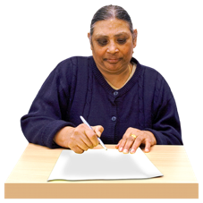 | If you are interested in this role, please fill out the application form below and send it back to us…
 | Email: madeline@stayuplate.org
 | Stay Up Late, 9 Russell Place, Brighton BN1 2RG
 | Phone: 01273 468168

If you have any questions please do get in touch.

