Sponsored walk ‘all night long’

 | On Saturday 24th October we are having the Stay Up Late Annual General Meeting, which is a big meeting held once a year to talk about what we do.
 | This is also the day where the clocks go back so it will be the longest Night of the year- we are going to make this ‘National Stay Up Late Night’!
 | The Stay Up Late team- Madeline, Paul, Holly and Kate - will be doing a sponsored walk all night long.
 | We will start at the North Laine Pub in Brighton at 11pm at night and finish at ‘Buddies’ café in Brighton at 8am the next day for breakfast.
 | We wanted the walk to be a challenge so we are going to walk 20 miles!
 | That does not mean that some people can’t come because of their needs- we will choose where we will walk when we know who wants to come.
 | If you can’t walk that far but want to help out, there are other things you can do…
 | We are looking for Marshals, who will meet us at the pub before we go and have a drink with us at 10pm - wave us off on our walk, or maybe walk with us for a short distance.
 | We are hoping there will also be some Driver volunteers, maybe Gig Buddy pairs, to meet us at certain points with food and drinks, and to give us lots of moral support.
 | Everyone is welcome to meet us for breakfast at Buddies café in Brighton at 8am when we finish our walk.
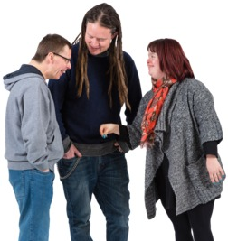 | We also need people to tell everyone about our walk so they can sponsor us. You can do this by sharing our local giving page which is where people can donate money
 | If you want to do the walk but are not sure if you will find it too difficult, we are doing a practice walk on Saturday 10th October
 | We will do our practice walk from Brighton to Rottingdean and back. We will start at 10am and finish at 2pm. The walk will be 5 miles long.
 | This will be a Happiness walk because it is World Mental Health Day. We will have a picnic, listen to happy songs, and learn how to stay positive and not get too stressed.
If you think you would like to be a part of the walk or help out in a different way, please call Kate and she can tell you more about it!
07514 622 204
Thank you!

From the
Stay Up Late Team.

SPONSOR US HERE!

https://localgiving.com/fundraising/allnightlong

