Quality Checker for Stay Up Late

Job application

Please write some examples that show that you have these qualities and experience:
 | Good listener
 | Able to communicate with different people
 | Good at interviewing
 | Computer skills
 | Campaigning
 | Thoughtful
 | Getting to the office
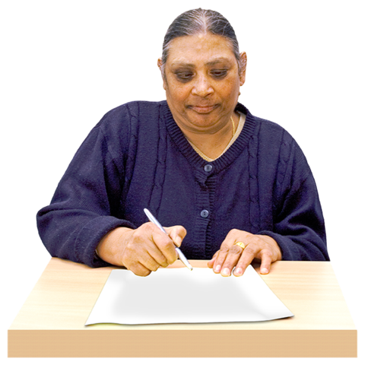 | When you have finished the application, please post it OR email it to…
 | Email: madeline@stayuplate.org
 | Stay Up Late, 9 Russell Place, Brighton BN1 2RG

